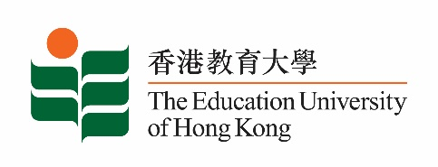
致： 傳媒機構採訪主任 3 July 2024
To : News Editors

香港教育大學2024年 7 月1 - 14日可供採訪之活動一覽
The Education University of Hong Kong (EdUHK) Events Calendar for 1-14 July 2024
本校誠邀 貴機構派員採訪下列活動。傳媒查詢，請聯絡教大傳訊處（電話：2948 6050）。
You are cordially invited to cover the events below. For media enquiries, please contact the Communications Office at 2948 6050.

以下活動或有人數限制，傳媒請預先向主辦部門登記。
There may be restrictions on the number of participants for the following event(s). Please contact the respective organiser(s) / department(s) for prior registration.

- 教大大埔校園 （新界大埔露屏路十號） / EdUHK Tai Po Campus (10 Lo Ping Road, Tai Po, New Territories)

日期  Date | 時間  Time | 活動  Event | 地點  Venue | 主辦部門及公眾查詢  Organiser &  Public Enquiry | 備註  Remarks
9 – 12 July 2024 | 9:00 am – 5:30 pm | The International Postgraduate Roundtable and Research Forum cum Summer School (IPRRFSS) 2024 | 教大大埔校園  EdUHK Tai Po Campus | 主辦部門 / Organiser:  Graduate School  研究生院  查詢 / Enquiries:  IPRRFSS Organizing Committee  Tel /電話: 2948 8205  Email /電郵: iprrfss@eduhk.hk | 免費入場，  歡迎各界人士參加。Free admission.  All are welcome.

